LI: to convert between units of measurement (g and kg and ml and l)

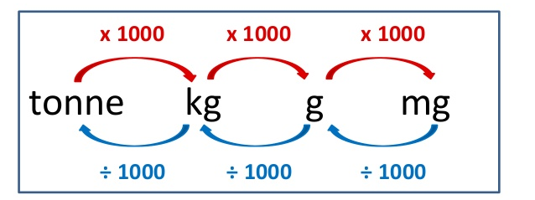
Use the same calculations above for litres and millilitres

Firstly, complete the grids for your group below:

Yellow and Green Groups

Litres | Millilitres | Litres | Millilitres
0.250 |  | 3.5
0.633 |  | 6.2
0.191 |  | 11.5
0.721 |  | 3.67
0.71 |  | 7.418
0.595 |  | 13.34

Litres | Millilitres | Litres | Millilitres
 | 266 |  | 9500
 | 985 |  | 3750
 | 333 |  | 6916
 | 620 |  | 4061
 | 459 |  | 2098
 | 69 |  | 12850

LI: to convert between units of measurement (g and kg and ml and l)

Use the same calculations above for litres and millilitres

Firstly, complete the grids for your group below:

Red and Blue Groups

Litres | Millilitres | Litres | Millilitres
 | 819 |  | 3593
 | 236 | 7.793
0.292 |  | 7.791
0.448 |  |  | 2718
 | 148 |  | 3079
0.876 |  | 1.193
0.529 |  |  | 3191
 | 403 | 2.257
 | 356 | 4.568
0.2 |  |  | 1772
0.05 |  |  | 17321
 | 55 | 21.7
 | 3 | 14.75
0.001 |  |  | 100855

Everyone to complete these two pages from Abacus (Yellows and Greens do not need to complete the word problems on each page).



