LQ: Where do people get advice and guidance from? (Islam and the Qur'an)

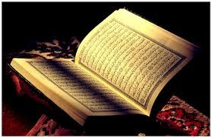

Commandments from Surah (chapter) 17 of the Qur'an

- Be kind to your parents, particularly in their old age.
- Always keep your promises.
- In daily life, be honest.
- Avoid gossip and slander.
- Do not take advantage of poor people or orphans.

Task One
Reflect on what we have learnt about commandments in Surah 17. Stick the Surah 17 sheet in your book, then copy and answer these questions in your RE book:
1. Why do you think these rules are included in the Qur'an?
2. Are they still relevant today?
3. Why are these rules good or bad?

Task Two
Now choose one of the commandments from Surah 17. Copy it into your book.
Write a description of what the world would be like if everyone followed this commandment.
You could draw a picture to complement your written description.
Task Three
Now write about the one text, book or piece of advice that has helped you most. Copy the relevant heading and the three sentences about it, then complete each sentence. If you have time, you could add an illustration.

Text or Book
A text/book which has given me guidance is....
The advice it gave me was.....
This advice is useful because......

or

Advice from another person
The most helpful advice I have received was from....
The advice they gave me was.....
This advice is useful because......

