LI: to convert between millimetres and centimetres, centimetres and metres, and between metres and kilometres

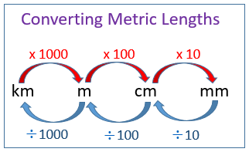

Yellow and Green Groups

Measure | Convert to CM | Measure | Convert to CM or MM
20mm |  | 30mm
10mm |  | 1cm
100mm |  | 15mm
50mm |  | 6cm
75mm |  | 8cm
Measure | Convert to MM | Measure | Convert to M
1.5cm |  | 100cm
2cm |  | 200cm
5cm |  | 50cm
10cm |  | 150cm
20cm |  | 500cm

Now complete Abacus Year 6, Textbook 1, Page 35. (Not no.16.)

LI: to convert between millimetres and centimetres, centimetres and metres, and between metres and kilometres

Red Group

Measure | Convert to CM | Measure | Convert to CM or MM
20mm |  | 30mm
10mm |  | 12cm
100mm |  | 150mm
50mm |  | 16cm
75mm |  | 18cm
Measure | Convert to MM | Measure | Convert to M
1.5cm |  | 100cm
2cm |  | 200cm
50cm |  | 500cm
10cm |  | 1000cm
40cm |  | 5000cm

Now complete Abacus Year 6, Textbook 1, Page 35. (Not no.16.)

LI: to convert between millimetres and centimetres, centimetres and metres, and between metres and kilometres

Blue Group

Measure | Convert to CM | Measure | Convert to M
25mm |  | 200cm
10mm |  | 800cm
100mm |  | 150mm
150mm |  | 1600cm
175mm |  | 8000cm
Measure | Convert to MM | Measure | Convert to KM
1.5cm |  | 1000m
2cm |  | 2500m
50cm |  | 100,000m
10cm |  | Measure | Convert to CM
40cm |  | 1km

Now complete Abacus Year 6, Textbook 1, Page 35. (Not no.16.)

Abacus Year 6, Textbook 1, Page 35. (Not no.16.)



