Monday 31st January 2022
LI To write a short story

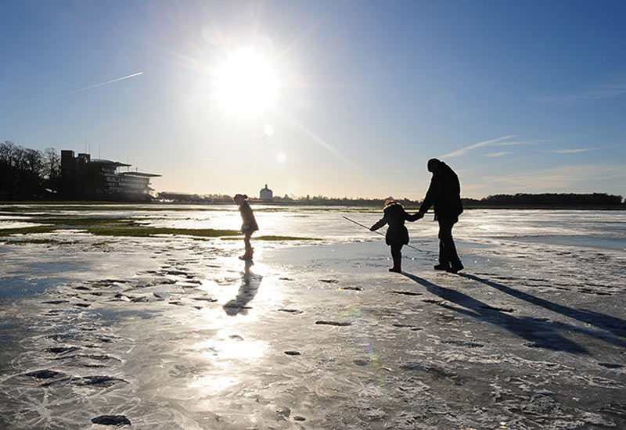

Write a story about this family’s trip to the beach.
Remember to include:
Descriptions – who is there, what are they thinking, feeling, seeing, smelling, hearing? Where are they? Describe the setting. Why are they there?
What do they say to each other, what do they do?
What happens?
Remember to use a capital letter at the beginning of every sentence, and for names. Use paragraphs to set your work out. And your BEST handwriting!
I look forward to reading your stories when you are back!

