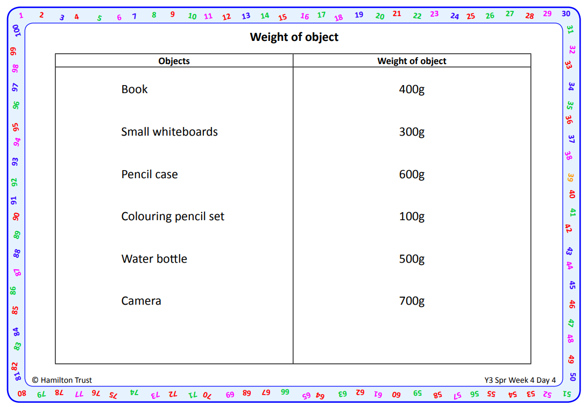
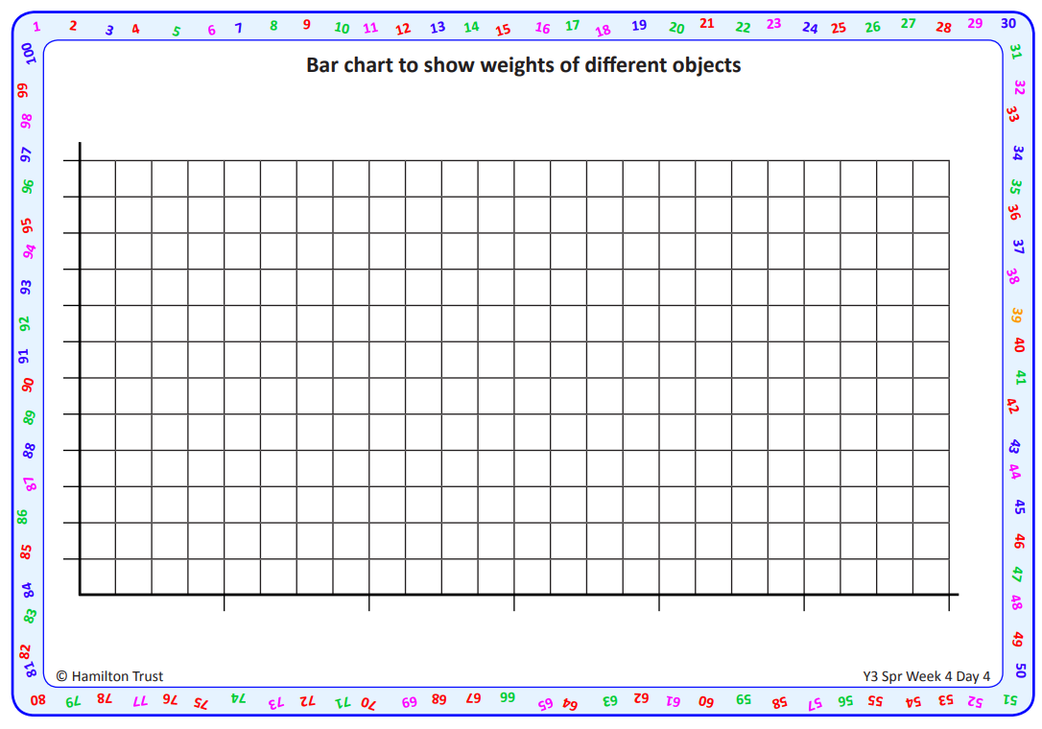

Which item is heaviest? ________________
Which item is lightest? _________________
How much heavier is the pencil case than the water bottle? ________________
What’s the difference in weight between the book and the camera? __________

