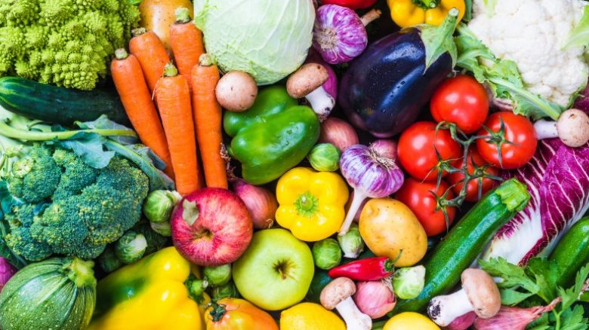
Personal Social and Emotional Development
School routines
Circle times
Environment
Healthy eating
Food
Communication and Language, Literacy
Recounts
Sequencing
Diary
Talk for writing
Learning digraphs.
Writing sounds and CCVC/CVCC words.
Reading CVCC/CCVC words and tricky words
Adjectives
Non-fiction texts
Writing sentences
Mathematics
Seasonal changes
Time
Counting in 2s
Number bonds
Addition/doubles
Subtraction/ halving
3D shape
Expressive Arts and design
Observational drawing
Bubble printing
Symmetrical paintings
Charanga music
Physical Development
PE – team games/ throw and catch/hit a target
Write dance
Outdoor play
Fine Motor activities
Forest School
The World
Seasons/spring
Habitats
Life cycles
Seeds
Growing
Vegetables

Growing

