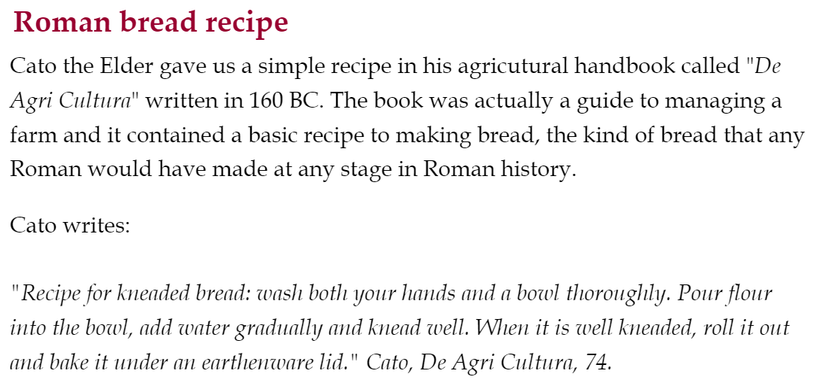
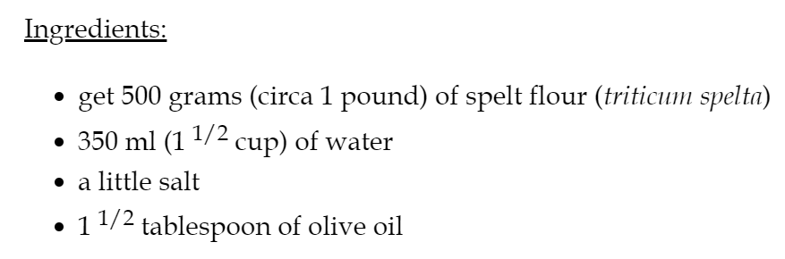
Cooking instructions
Preheat an oven to 180º C (350 F).
In a large bowl, add the spelt flour along with a little salt.
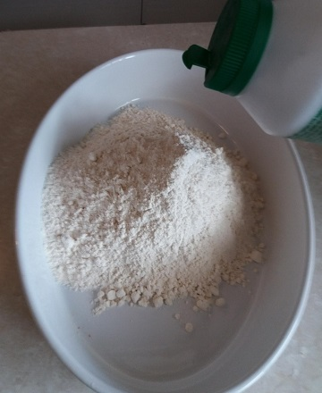
Mix it.
Pour the olive oil in the bowl.
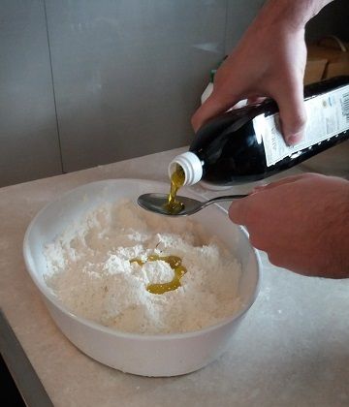
Gradually add the water and continue mixing until you get a dough that isn't too sticky or floury.
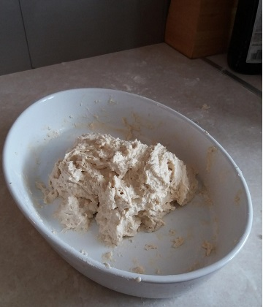
Knead the dough and make it into a circular shape. Make marks on the top of the dough with a knife dividing it into 8.

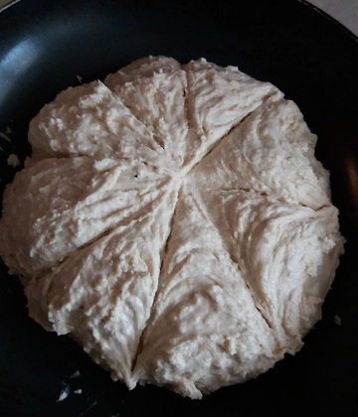

Bake for 45 mns in the oven. If you can cover it with a lid.
Your Roman bread is ready to be served. Please note that since no yeast is being used, the bread won't have risen much if at all.

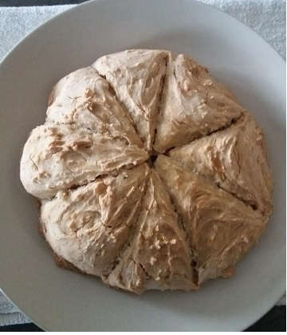
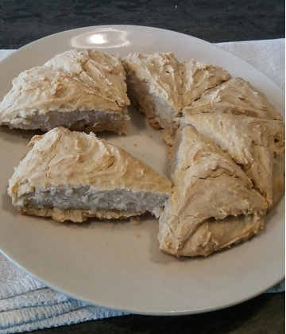

Our bread actually looks similar to the one found in Pompeii:
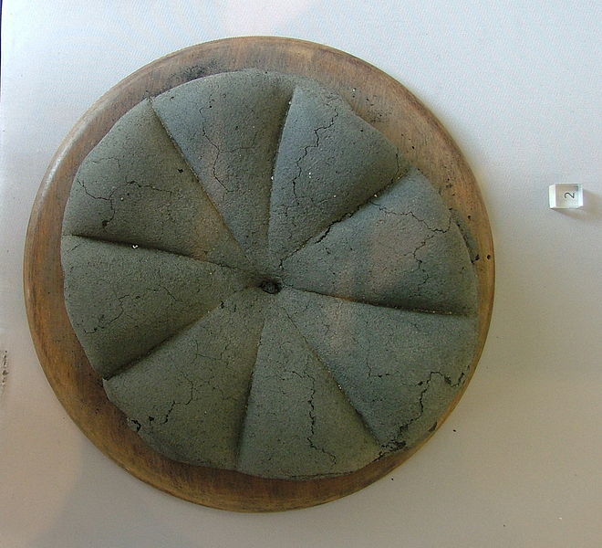
Ancient Roman loaf of bread
found at Pompeii CC BY-SA 2.0 it
Note that the bread in the picture above is black as it was carbonized following the volcano eruption!

