Special Educational Needs and Disabilities (SEND) Information Report

Elham Church of England Primary School

Inclusion Team
SEND Governor:
Ed Robbins, Chair of Governors
Inclusion Lead/SENCO/SEND Team:
Joseph Magliocco, Headteacher,
Victoria Hall, SENCO
Contact No. 01303 840325
Inclusion Team:
victoriahall@elham.kent.sch.uk
elhamheadteacher@elham.kent.sch.uk

Approved by: | Joseph Magliocco | Date: 22nd September 2026
Last reviewed on: | 7th October 2026
Next review due by: | September 2027

Contents
1. What types of SEND does the school provide for? 4
2. Which staff will support my child? 5
3. What should I do if I think my child has SEND? 7
4. What happens if the school identifies a need? 8
5. How will the school measure my child’s progress? 9
6. How will I be involved in decisions made about my child’s education? 10
7. How will my child be involved in decisions made about their education? 11
8. How will the school adapt its teaching for my child? 12
9. How will the school evaluate whether the support in place is helping my child? 13
10. How will the school ensure my child has appropriate resources? 13
11. How will the school make sure my child is included in activities alongside pupils who don’t have SEND? 14
12. How does the school make sure the admissions process is fair for pupils with SEN or a disability? 15
13. How does the school support pupils with disabilities? 15
14. How will the school support my child’s mental health and emotional and social development? 16
15. What support is in place for looked-after and previously looked-after children with SEN? 16
16. What support will be available for my child as they transition between classes or settings or in preparing for adulthood? 17
17. What support is available for me and my family? (Local Offer) 18
18. What should I do if I have a complaint about my child’s SEND support? 19
19. Supporting Documents…………………………………………………………………………………………………………….19
20. Glossary 20

Dear parents and carers,
The aim of this Information Report is to explain how we implement our SEND policy. In other words, we want to show you how SEND support works in our school.
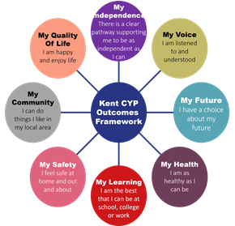
As educational professionals, we are all working towards the ultimate goal of growing independent young people as they prepare for adulthood. All provision and support we provide is working towards achieving the Kent Children and Young People (CYP) Outcomes Framework:

If you want to know more about our arrangements for SEND, read our SEND policy alongside this Information Report.
You can find our SEND policy on our website Elham Church of England Primary – SEND Policy.
Note: If there are any terms we’ve used in this information report that you’re unsure of, you can look them up in the Glossary at the end of the report.

1. What types of SEND does the school provide for?

Our school provides for pupils with the following needs (as outlined in the SEND Code of Practice 2015):

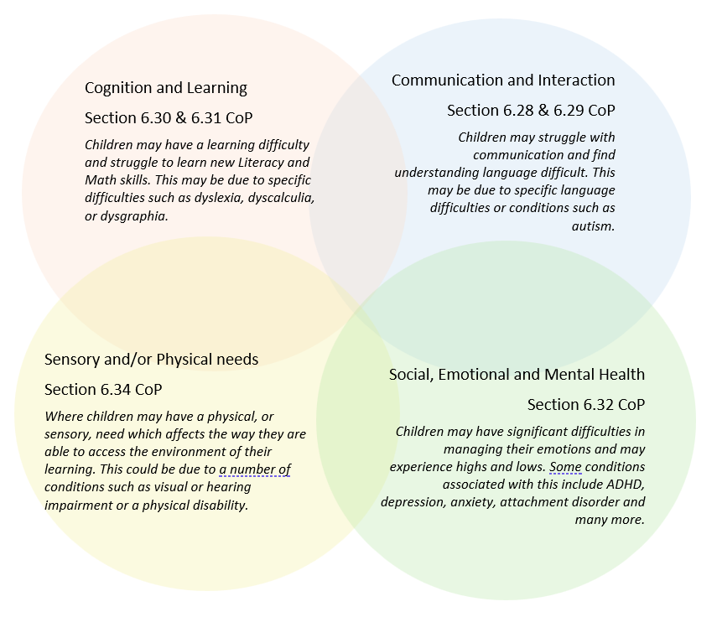

Often you will find that children’s needs overlap and are rarely confined to one area of need, which is why it is important to gain a wholistic overview of your child.
More information about the Areas of Need can be found in the Special educational needs and disability code of practice: 0 to 25 years (link below).
SEND_Code_of_Practice_January_2015.pdf (publishing.service.gov.uk)


2. Which staff will support my child, and what are their key responsibilities?

At Elham Church of England Primary School all staff are considered responsible for supporting the needs of pupils with SEND. Our staff are committed to regular, high-quality training to ensure that they have the knowledge and skills to better meet a wide range of pupil needs.
Below outlines key staff who will be supporting your child. Please note that this list is not exhaustive.
Mrs Victoria Hall – SENCO
‘I am the school's SENCO (Special Educational Needs Coordinator) and I am out of class on Thursdays to fulfil this role. My role is to oversee and evaluate our SEN provision and to ensure that children receive appropriate support for their individual needs. I work closely with class teachers, teaching assistants, families and external professionals to help children make progress and participate fully in school life. If you would like to discuss SEN support for your child or have another SEN-related concern, please contact me by email and I will endeavour to respond as soon as possible.’
Mrs Catherine Foster – Teaching Assistant leading many of our interventions
Mr Joseph Magliocco – Headteacher
‘As Headteacher, I have overall responsibility for the education and learning of all children at Elham Church of England Primary School, including children with special educational needs and/or disabilities (SEND). While I am not the school’s SENCO, I work closely with the SENCO and staff to ensure that children with SEND receive the support they need to learn, achieve and thrive.
Parents and families are always welcome to contact me if they would like to discuss any aspect of their child’s learning, progress or support. I am always happy to listen and work with families to consider how we can best support their child.’
Our Special Educational Needs Co-ordinator, or SENCO
The named SENCO is Mrs Victoria Hall
Our SENCO is Mrs Victoria Hall
They have 6 years experience in this role. They are a qualified teacher and currently teach year 5 and 6 in Peake Class.
They achieved the National Award in Special Educational Needs Co-ordination in 2020.
Mrs Hall is also currently undertaking a National Professional Qualification in Senior Leadership.
Class/subject teachers
All of our teachers receive in-house SEN training, and are supported by the SENCO to meet the needs of pupils who have SEN.
We have also received training by the Specialist Teaching and Learning Support (STLS) team on Good Autism Practice (GAP).
Teaching assistants (TAs)
We have a team of 3 TAs, including 1 higher-level teaching assistant (HLTA) who are trained to deliver SEN provision.
We have three teaching assistants who are trained to deliver interventions such as Little Wandle Rapid Catch Up, Talking Hands, NCETM Ready to Progress, Drawing and Talking.
External agencies

Sometimes we need extra help to offer our pupils the support that they need. Whenever necessary we will work with external support services to meet the needs of our pupils with SEND and to support their families. These may include:

- Child and adolescent mental health services (CAMHS)
- Education welfare officers
- Educational psychologists
- GPs or paediatricians

- Occupational therapists
- Play Therapists
- Behaviour coaches
- Safeguarding services

- School nurses
- SEND Inclusion Advisor
- Specialist Teacher Service
- Speech and language therapists
- Voluntary sector organisations

3. What should I do if I think my child has SEND?

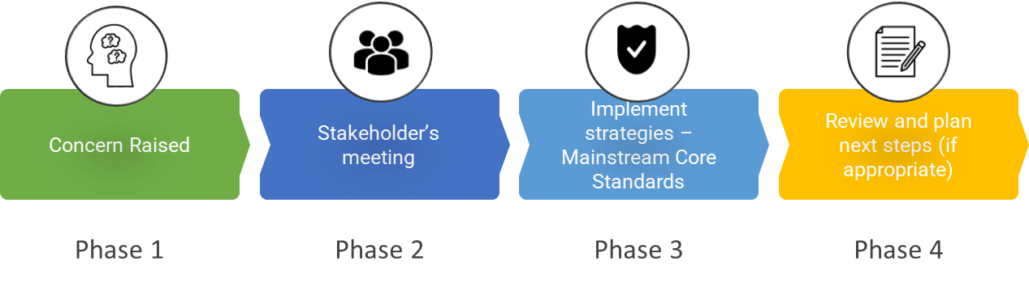

Phase 1 | If you think your child might have SEND, raise your concern with the school so that the SENCO is aware.  We value the views of parents and carers, and recognise that you know your child best. We aim to work in partnership with families when identifying needs, putting support in place and reviewing progress.  If you have concerns about your child's learning or development, please speak to your child's class teacher or the SENCO. This can be done via appointment made at the office, in person at drop-off or pick-up, by messaging your child’s class teacher on ClassDojo or by emailing Mrs Hall or Mr Magliocco.  We welcome conversations with families and encourage you to raise concerns early so that we can work together to identify appropriate support.  Parents and carers will be involved in the development and review of their child's Individual Support Plan where one is in place. We value your contribution to identifying what works well for your child and what further support may be helpful.
Phase 2 | We will meet with you to discuss your concerns and try to get a better understanding of what your child’s strengths and difficulties are. Together we will decide what outcomes to seek for your child and agree on next steps. We will make a note of what’s been discussed and add this to your child’s record.
Phase 3 | We will implement the agreed strategies and monitor these over an agreed period of time. These are likely to be universal strategies set out in the mainstream core standards. A copy of this can be found here: https://www.kelsi.org.uk/__data/assets/pdf_file/0005/117257/Special-educational-needs-mainstream-core-standards-guide-for-parents.pdf . This will initiate the ‘Graduated Approach’ where support will be continually reviewed. See next page for more details.
Phase 4 | If we decide that your child needs SEND support, we will formally notify you and your child will be added to the school’s SEND register. They will receive additional support and this will be reviewed using the assess, plan, do, review model.

4. What happens if the school identifies a need?
At Elham Church of England Primary School, we use a graduated approach to identify and respond to children who may experience barriers to learning. This begins with a universal offer of high-quality teaching and support for all children. This includes high expectations, an ambitious and supportive curriculum, positive relationships between children and their teachers, adaptive teaching and a calm, supportive learning environment.
If the teacher notices that a pupil is having difficulties, they try to find out if the pupil has any gaps in their learning. If they can find a gap, the school will provide appropriate support. Pupils who don’t have SEND usually make progress quickly once the gap in their learning has been filled.
If the pupil is still finding it difficult to make the expected progress, the teacher will talk to the SENCO, and will contact you to discuss the possibility that your child has SEND.
Children may be identified as needing additional or more targeted support. Teachers use a range of assessment information and professional knowledge to identify children who may be experiencing barriers to learning. This can include formal and formative assessments, observations, conversations with children and their families, and advice from external professionals, where appropriate.
Where a child is identified as experiencing barriers to learning, we will work with the child and their family to understand their strengths, needs and the support that may be helpful. We will agree appropriate strategies and outcomes and use an Assess, Plan, Do, Review cycle to monitor their impact. Parents and carers will be involved in this process and kept informed about the support being provided and their child's progress.
Support may initially consist of adjustments and strategies within high-quality classroom teaching. Where a child requires more targeted support, this may include additional interventions or provision from school staff. Support will be reviewed at an agreed point to consider its impact and determine appropriate next steps.
If a child is identified as requiring provision that is additional to or different from that normally available to children of the same age, they may be identified as receiving SEND Support and placed on the school's SEND register. Where appropriate, we may seek advice or support from external professionals. This would be discussed with the child and their family, and any recommendations would be incorporated into the Assess, Plan, Do, Review cycle.
This is a similar process to when concerns are raised by a family.

5. How will the school measure my child’s progress?
We will follow the ‘graduated approach’ to meeting your child’s SEND needs.
The graduated approach is a 4-part cycle of assess, plan, do, review.
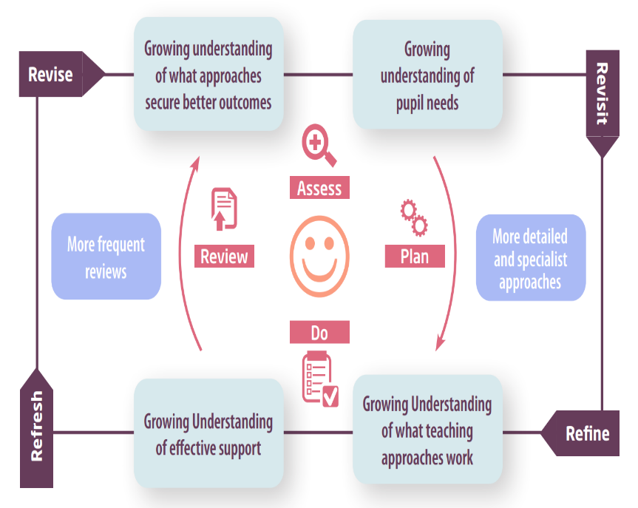

Assess | If your child is not making the expected level of progress, we will make an assessment to find out what strengths and difficulties your child has. We will ask for you and your child’s input, as well as getting help from external professionals where necessary.
Plan | In discussion with you and your child, we will decide what outcomes we are hoping to achieve. We will make a plan of the support we will offer your child to help them meet those outcomes. We will make a record of this and share it with you and all relevant school staff.
Do | We will put our plan into practice.  The class teacher, with the support of the SENCO, will be responsible for working with your child on a daily basis, and making sure the support we put in place is having the impact we intended.
Review | We will assess how well the support we put in place helped the pupil to meet the outcomes we set. We will use our improved understanding of your child’s needs to improve the support we offer; this may mean the Plan, Assess, Do, Review cycle continues.

6. How will I be involved in decisions made about my child’s education?

We hold Parent Teacher Consultations termly, providing an opportunity to discuss your child's progress and learning. As a school, Elham Church of England Primary School operates an ‘open-door policy’ for all families. We encourage pupils and families to speak with their class teacher or the SENCO at any point during the academic year if they have questions or concerns about their child's learning, progress or support. You do not need to wait until a Parent Teacher Consultation to discuss something that is important to you or your child.
During discussions around your child’s progress and the graduated approach (see above), your child’s class teacher and/or the SENCO will talk with you to:
- Set clear outcomes for your child’s progress
- Review progress towards those outcomes
- Discuss the support we will put in place to help your child make that progress
- Identify what we will do, what we will ask you to do, and what we will ask your child to do

We know that you’re the expert when it comes to your child’s needs and aspirations. So, we want to make sure you have a full understanding of how we’re trying to meet your child’s needs, so that you can provide insight into what you think would work best for your child.
We also want to hear from you as much as possible so that we can build a better picture of how the SEND support we are providing is impacting your child outside of school.
If your child’s needs or aspirations change at any time, please let us know right away so we can keep our provision as relevant as possible.
If you have concerns that arise between these meetings, please contact Mrs Hall via email (victoriahall@elham.kent.sch.uk) or your child’s class teacher on ClassDojo. If you are unhappy with how your concerns have been dealt with, our complaints policy is available here, along with information about the complaints process.

7. How will my child be involved in decisions made about their education?

The level of involvement will depend on your child’s age and individual needs. We recognise that no two pupils are the same, so we will decide on a case-by-case basis, with your input.

We may seek your child’s views by asking them to:
- Attend meetings to discuss their progress and outcomes
- Prepare a presentation, written statement, video, drawing, etc.
- Discuss their views with a member of staff who can act as a representative during the meeting

- Complete a survey

8. How will the school adapt its teaching for my child?
More information on how we adapt teaching and learning to support access for all pupils and families can be found on the school’s Accessibility Plan, linked here.
Your child’s teacher(s) is/are responsible and accountable for the progress and development of all the pupils in their class.
High-quality teaching is our first step in responding to your child’s needs. We will make sure that your child has access to a broad and balanced curriculum in every year they are at our school.
We will adapt our approaches to how we teach to suit the way the pupil works best. There is no 'one size fits all’ approach to adapting the curriculum, we work on a case-by case basis to make sure the adaptations we make are meaningful to your child and are guided by the Mainstream Core Standards in the first instance.
These adaptations may include:
- Adapting our approaches, for example, giving longer processing times, pre-teaching of key vocabulary, reading instructions aloud, etc.

- Adapting our resources and staffing

- Using recommended aids, such as laptops, coloured overlays, now and next boards, larger font, use of Widgit .etc.

- Teaching assistants or support staff will support pupils appropriately depending on their presentation of need

- Scaffolding lesson materials

- Targeted questioning to support thinking and learning

We may also provide the following interventions:
Little Wandle Rapid Catch-up
Little Wandle Keep Up
Drawing and Talking
Ready to Progress Maths
Social Stories
Additional Handwriting Practice
These interventions are part of our contribution to Kent County Council’s local offer.

9. How will the school evaluate whether the support in place is helping my child?
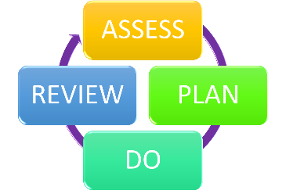
We will evaluate the effectiveness of provision for your child by:
- Reviewing their progress towards their goals each term
- Discussing pupil progress during half-termly Pupil Progress Meetings between the class teacher(s) and the headteacher
- Reviewing the impact of interventions after a maximum of 8 weeks (one half-term).
- Using pupil questionnaires
- Monitoring by the SENCO
- Using provision maps to measure progress
- Holding an annual review (if they have an education, health and care (EHC) plan)

10. How will the school ensure my child has appropriate resources?
It may be that your child’s needs mean we need to provide additional resources such as:
- Adaptations to in class support, such as from a 1:1 adult
- Further training for our staff
- External specialist expertise
- Additional teaching and learning resources, such as the use of Clicker or an automatic reading pen
Where appropriate, we will consult with external agencies to get recommendations on what will best help your child access their learning and use our best endeavours to ensure these are supplied.

11. How will the school make sure my child is included in activities alongside pupils who don’t have SEND?


The expectation is that all schools provide an inclusive provision for all pupils. It may be necessary for some pupils to receive interventions in addition to a broad and balanced curriculum.
All of our extra-curricular activities and school visits are available to all our pupils, including our before and after-school clubs.
All pupils are encouraged to go on our school trips, including our residential trip(s) that take place in Year 5/6.
All pupils are encouraged to take part in [sports day/school plays/special workshops/collective worship and sporting events].
No pupil is ever excluded from taking part in these activities because of their SEN or disability and we will make whatever reasonable adjustments are needed to make sure that they can be included.

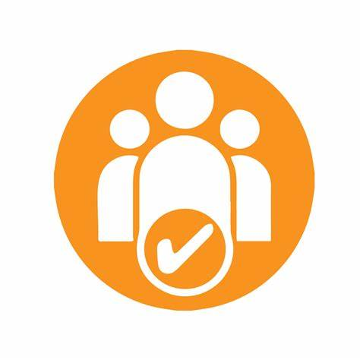
12. How does the school make sure the admissions process is fair for pupils with SEN or a disability?

We welcome applications from children with special educational needs and/or disabilities (SEND). Admission decisions are made in accordance with our published admissions arrangements and our legal duties, including those under the Equality Act 2010. A child will not be refused admission because they have SEND or a disability.
Where Elham Church of England Primary School is named in a child's Education, Health and Care (EHC) plan, the child will be admitted to the school. These children are admitted before places are allocated under the school's oversubscription criteria, and the Published Admission Number is reduced accordingly.
Our oversubscription criteria are applied fairly and consistently and do not disadvantage children because of SEND or disability. Our admissions arrangements include provision for medical, health and special access reasons, in accordance with the school's legal obligations, including those under the Equality Act 2010. Where appropriate, priority may be given to children whose physical or mental impairment means that they have a demonstrable and significant need to attend a particular school.
Full details of our admissions arrangements, including our oversubscription criteria, appeals and waiting lists, can be found in our Admissions Policy.

13. How does the school support pupils with disabilities?


At Elham Church of England Primary School, we are committed to ensuring that disabled pupils are treated with dignity, respect and fairness and are able to participate fully in school life alongside their peers. We recognise our duties under the Equality Act 2010 and consider reasonable adjustments on an individual basis to prevent disabled pupils from being placed at a substantial disadvantage.
We seek to identify and remove barriers to learning and participation through high-quality teaching, adaptive practice, reasonable adjustments and appropriate resources. This may include visual timetables and visual supports, scaffolding, assistive technology, sensory and communication resources, adaptations to the physical environment and adjustments to routines, activities and transitions.
We consider accessibility when planning lessons, educational visits, Forest School, sporting activities, performances, play and other enrichment opportunities. Where an environment or activity creates a barrier, we will consider reasonable alternatives or adaptations so that disabled pupils can participate wherever reasonably practicable.
We also recognise that disabled pupils may be particularly vulnerable to bullying, prejudice, social isolation and safeguarding concerns. Our Anti-Bullying Policy and Safeguarding and Child Protection Policy set out how we identify and respond to these risks. We challenge discriminatory language and behaviour and ensure that children with disabilities are supported to communicate their views and have their voices heard.
We work with pupils and their families to understand individual needs and agree appropriate adjustments and support. We also recognise that disability can sometimes create barriers to attendance and will work with pupils and families to identify and reduce these barriers.
Our Accessibility Plan sets out the steps the school is taking to improve access to the curriculum, physical environment and information, and to promote the participation and inclusion of disabled pupils. The Accessibility Plan is reviewed at least annually. There is a link to the Accessibility Plan here.
You’re disabled under the Equality Act 2010 if you have a physical or mental impairment that has a ‘substantial’ and ‘long-term’ negative effect on your ability to do normal daily activities.

14. How will the school support my child’s mental health and emotional and social development?
At Elham Church of England Primary School, we recognise that children learn best when they feel safe, valued, understood and supported. We place a strong emphasis on positive relationships, emotional wellbeing and helping children to develop the confidence, resilience, empathy and social skills they need to thrive.
Mental health and emotional wellbeing are supported through our universal provision for all children. Our PSHE curriculum, including the Kapow programme, provides opportunities for children to learn about relationships, emotions, wellbeing and staying safe. We also use Zones of Regulation across the school to help children recognise and communicate their feelings and develop strategies to support their emotional regulation. In EYFS and KS1, there is a particular focus on identifying and talking about feelings, with increasing emphasis on developing and applying regulation strategies as children progress through the school. We also make use of appropriate external speakers and experiences to complement this provision.
Children are encouraged to talk to any adult in school if they have a worry or concern. All members of staff have a responsibility to safeguard children and this includes being alert to concerns about their mental health, emotional wellbeing and social development. We aim to create an environment where children know that adults will listen to them and take their concerns seriously.
We listen to pupils and value their views. This is particularly important for children with SEND, who may sometimes experience additional communication, social or emotional barriers. We consider how individual children communicate and make appropriate adjustments so that they can express their views, contribute to decisions about their support and have their voices heard.
Where a child needs additional pastoral or emotional support, we consider their individual needs and work with the child and their family to identify appropriate strategies. This may include targeted SEMH support, an Individual Behaviour Plan or Pastoral Support Plan, or support from appropriate school staff or external professionals. Where additional support is needed, this is reviewed regularly and adapted according to its impact.
Our approach to behaviour is positive, consistent and supportive. We recognise that behaviour can be a form of communication and may indicate that a child is experiencing an unmet need or difficulty. Where a child is struggling to meet expectations, we seek to understand what may be contributing to this and consider appropriate adjustments to the support and strategies used. Clear expectations for safe, respectful and responsible behaviour remain in place for all children.
We take bullying, harassment and prejudice-based behaviour seriously. Our Anti-Bullying Policy recognises that some children, including children with SEND, may be particularly vulnerable to bullying, social isolation or discriminatory behaviour. We challenge discriminatory language and behaviour, investigate concerns and provide appropriate support to children involved. We also work to develop a culture of respect, tolerance, empathy and inclusion.
We work closely with parents and carers when concerns arise and encourage families to speak to us at an early stage. Our aim is to identify concerns promptly, understand what may be contributing to a child's difficulties and work together to put appropriate support in place.
We provide support for pupils to progress in their emotional and social development in the following ways:
- Pupils with SEND are encouraged to be part of the school council
- Pupils with SEND are also encouraged to attend our after-school clubs and wrap-around provision, to promote teamwork and support the building of friendships

15. What support is in place for looked-after and previously looked-after children with SEND?


At Elham Church of England Primary School, the Headteacher works closely with the SENCO to ensure that the needs of looked-after and previously looked-after children with SEND are understood and appropriately supported. We work with teachers to consider how a child’s care experience and SEND may interact and what this means for their learning, development and wellbeing.
Looked-after and previously looked-after children with SEND are supported through the same graduated approach as other children with SEND. Where a looked-after child has a Personal Education Plan (PEP), we ensure that this complements any SEND support plan or Education, Health and Care (EHC) plan, so that the different aspects of their support work together.

16. What support will be available for my child as they transition between classes or settings or in preparing for adulthood?
Between years

To help pupils with SEND be prepared for a new school year we:
- Dedicate time for your child’s next teacher and their current teacher to meet and to discuss existing support, possible next steps, and the best ways to support your child's learning
- Organise a ‘Transition Day’ in the Summer term where children meet their new teacher, visit their new classroom and spend time with their new peers
- Can create social stories and transition books, containing photographs of key information, such as new teachers and staff, the new place to find the toilets and hang their bag, what their new classroom will look like etc.
- Spend time talking with your child and yourselves to discuss any anxieties or thoughts that they or you have about the transition to a new year group
- Hold Meet the Teacher events at the beginning of a new school year to give children and their families the opportunity to meet and discuss the transition
Between schools
When your child is moving to our school or moving on from our school, we will ask for information from their current setting and offer information to the new setting. This will always be done in consultation with you.
The SENCO of the secondary school will come into our school for a meeting with our SENCO. They will discuss the needs of all the pupils who are receiving SEND support. If your child is joining us from an Early Years setting, our SENCO will contact the SENCO at the Early Years to discuss any new starters.
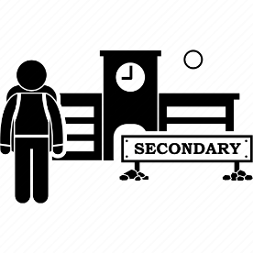
Pupils will be prepared for the transition by:
- Practising with a secondary school timetable (Y6)
- Learning how to get organised independently (Y6)
- Plugging any gaps in knowledge (Y6)
- Receiving stay and play days to experience our setting and meet their teachers and peers (EYFS)
- Attending our Open Day to see the school site (EYFS)
- Families being offered parent workshops, such as on Phonics, to understand how you can support your child at home (EYFS)
- A staggered start to the school timetable, with days gradually building to full time (if agreed with our families) (EYFS)

17. What support is available for me and my family?
If you have questions about SEND, or are struggling to cope, please get in touch to let us know. We want to support you, your child and your family.
To see what support is available to you locally, have a look at Kent County Council’s (KCC) local offer. KCC publishes information about the local offer on their website:
https://www.kent.gov.uk/education-and-children/special-educational-needs-and-disabilities/about-the-send-local-offer
https://local.kent.gov.uk/kb5/kent/directory/localoffer.page?localofferchannel=0
Our local special educational needs and disabilities information advice and support services (SENDIASS) organisations are:
Kent
Local charities that offer information and support to families of pupils with SEND are:
https://includesustoo.org.uk/
https://bechange.org.uk/
https://southkentmind.org.uk/
https://www.doversmartproject.co.uk/
National charities that offer information and support to families of pupils with SEND are:
- IPSEA
- SEND family support
- NSPCC
- Family Action
- Special Needs Jungle

18. What should I do if I have a complaint about my child’s SEND support?
We encourage parents and carers to raise concerns as early as possible so that we can try to resolve them quickly and informally. Concerns should normally be raised with the class teacher in the first instance. If the concern cannot be resolved, or you wish to make a formal complaint, this can be submitted in writing using the school’s Complaints Form and Policy.
Formal complaints are considered through the stages set out in our Complaints Policy, with the opportunity for the matter to be reviewed by the Governing Body where appropriate. We will make reasonable adjustments where needed to ensure that our complaints procedure is accessible.
Our full Complaints Form and Policy, including details of how to make a formal complaint, is available on the school website.
If you are not satisfied with the school’s response, you can escalate the complaint. In some circumstances, this right also applies to the pupil themselves.
To see a full explanation of suitable avenues for complaint, see pages 246 and 247 of the SEND Code of Practice.
If you feel that our school discriminated against your child because of their SEND, you have the right to make a discrimination claim to the first-tier SEND tribunal. To find out how to make such a claim, you should visit: https://www.gov.uk/complain-about-school/disability-discrimination
You can make a claim about alleged discrimination regarding:
- Admission
- Exclusion
- Provision of education and associated services
- Making reasonable adjustments, including the provision of auxiliary aids and services
Before going to a SEND tribunal, you can go through processes called disagreement resolution or mediation, where you try to resolve your disagreement before it reaches the tribunal.
If you disagree with the school, local authority or another organisation about your child’s special educational needs provision, independent disagreement resolution and mediation services are available.
In Kent, these services are provided by Global Mediation. The service is free and independent and can help families and education professionals work towards resolving disagreements about SEND provision and Education, Health and Care (EHC) plans.
Global Mediation: 020 8441 1355
Email: sen@globalmediation.co.uk
Website: www.globalmediation.co.uk

19. Supporting documents

- Equality Information and Objectives Policy
- Child Protection Policy
- Behaviour and Positive Relationships Policy
- SEND Accessibility Plan 2026/27–2029/30
- Attendance Policy
- SEND policy
- Admissions Policy
- Anti-Bullying Policy
- Complaints Form and Policy
- Health & Safety Policy

- SEN & Disabilities Code Of Practice 2015
- Mainstream Core Standards

20. Glossary
- Access arrangements – special arrangements to allow pupils with SEND to access assessments or exams
- Annual review – an annual meeting to review the provision in a pupil’s EHC plan
- Area of need – the 4 areas of need describe different types of needs a pupil with SEND can have. The 4 areas are communication and interaction; cognition and learning; physical and/or sensory; and social, emotional and mental health needs.
- CAMHS – child and adolescent mental health services
- Differentiation – when teachers adapt how they teach in response to a pupil’s needs
- EHC needs assessment – the needs assessment is the first step on the way to securing an EHC plan. The local authority will do an assessment to decide whether a child needs an EHC plan.
- EHC plan – an education, health and care plan is a legally-binding document that sets out a child’s needs and the provision that will be put in place to meet their needs.
- First-tier tribunal/SEND tribunal – a court where you can appeal against the local authority’s decisions about EHC needs assessments or plans and against discrimination by a school or local authority due to SEND
- Graduated approach – an approach to providing SEND support in which the school provides support in successive cycles of assessing the pupil’s needs, planning the provision, implementing the plan, and reviewing the impact of the action on the pupil
- Intervention – a short-term, targeted approach to teaching a pupil with a specific outcome in mind
- Local offer – information provided by the local authority which explains what services and support are on offer for pupils with SEND in the local area
- Outcome – target for improvement for pupils with SEND. These targets don't necessarily have to be related to academic attainment
- Reasonable adjustments – changes that the school must make to remove or reduce any disadvantages caused by a child’s disability
- SENCO – the special educational needs co-ordinator
- SEN – special educational needs
- SEND – special educational needs and disabilities
- SEND Code of Practice – the statutory guidance that schools must follow to support pupils with SEND
- SEND information report – a report that schools must publish on their website, that explains how the school supports pupils with SEND
- SEND support – special educational provision which meets the needs of pupils with SEND
- Transition – when a pupil moves between years, phases, schools or institutions or life stages

