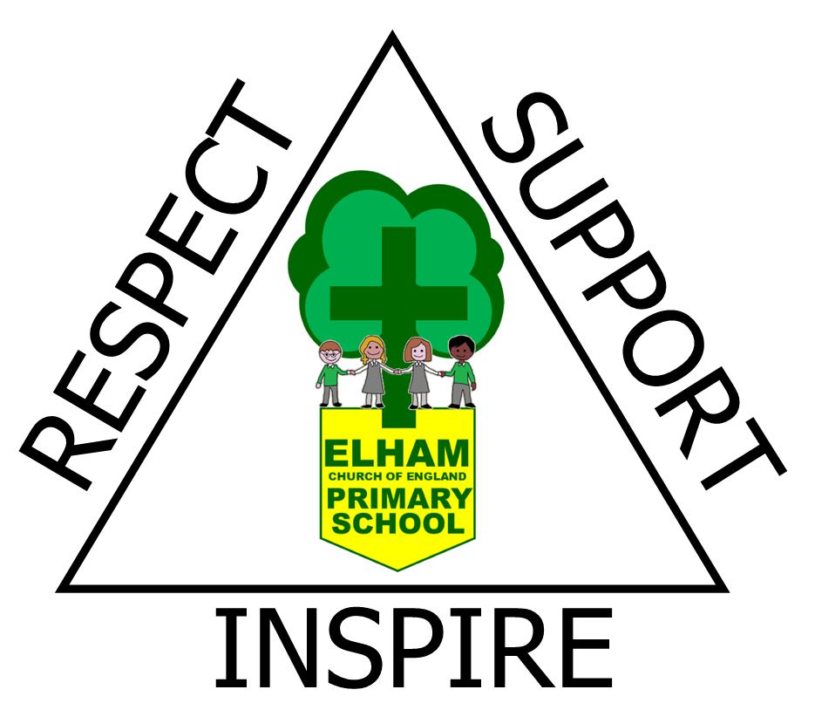 | Long Term Plan  Computing

Year 1/2

 | Autumn | Spring | Summer
A | Improving Mouse Skills | Programming 1: Algorithms unplugged | Computing Systems and Networks 2: Word Processing
B | Programming Option 1: Bee-bots | Creating Media: Digital Imagery | Data Handling: International Space Station

Year 3/4

Cycle | Term 1 | Term 2 | Term 3 | Term 4 | Term 5 | Term 6
A | Google: Emailing | Programming: Scratch | Video trailers - option 2 using iPads | Google: Creating media - website design | Programming 1: Further coding with scratch | Computational thinking
B | Computing Systems and Networks 1: Networks | Data handling: Comparison cards databases | Computing Systems and Networks 3: Journey inside a computer | Google: Computing systems and networks: Collaborative learning | Data handling: Investigating weather | Skills showcase: HTML

Year 5/6

 | Term 1 | Term 2 | Term 3 | Term 4 | Term 5 | Term 6
A | Programming 2: Micro:bit | Data Handling: Mars Rover 1 | Skills Showcase: Mars Rover 2 | Computing Systems and Networks: Bletchley Park and the history of computers | Computing systems and networks: Exploring AI | Skills Showcase: Inventing a product
B | Programming 1: Music | Stop-motion animation | Computing systems and networks: search engines | Data handling 1: Big Data 1 | Data handling 2: Big Data 2 | Programming: intro to python

